**Abstineatis**

**Entrepreneurial**

**Business Engineering Plan**



Executive Summary

Abstineatis Process Mining is a Business Process Management (BPM) consultation firm using the specialised field of process mining to provide companies with accurate analytics on the performance of their processes.

We add value to businesses by supplying everything necessary to apply process mining techniques to improve business processes using our model of three main value propositions, as discussed in Chapter I.

This document details plans for all aspects of the business. First, we define the positioning of the business within the context of the greater market, and detail expectations for the future of the market and our position in it.

Next, we discuss the important aspects of Financial Management. We discuss projections for the cash-to-cash cycle within the business as well as projections on the expected financial situation of the business for the first five years.

This is followed by an exploration of the industry within which we position ourselves. We discuss the competitive landscape within which we find ourselves, and risk mitigation strategies to avoid failure in the greater competitive context.

Finally, we discuss important aspects of investment in the business. We define the type of investment we are looking for and detail what this investment will be used for. We also discuss the Million Rand Runway for the business.

Core Value Proposition

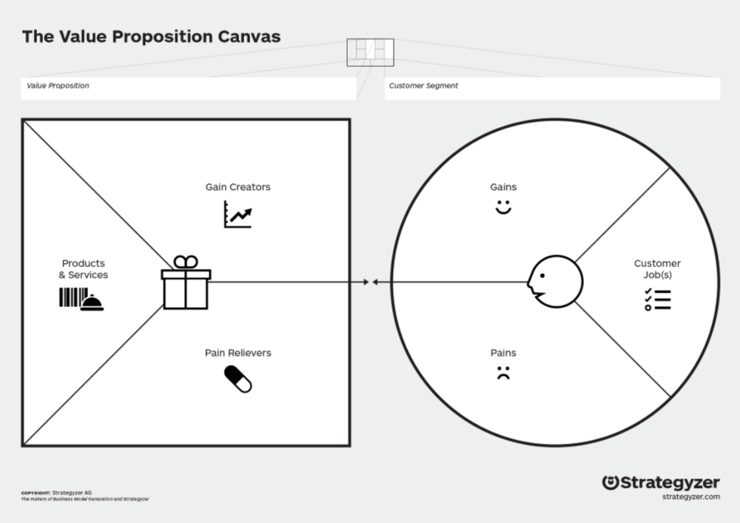

Sales of products

Delivery of services

Satisfying customers

Sub-optimal business processes

Late orders

Customers not served quickly

Profit

Customer relations

Customer base expansion

Analytics software

Training

Implementation of IT support

Analytics training

Control over business processes

Improve processes

Customer service process analysis

Table of Contents

Executive Summary I

Core Value Proposition I

Table of Contents II

List of Tables II

List of Figures II

I. The Business 1

The Market 1

The Future 2

II. Financial Management 4

Cash to Cash Cycle 4

The Finances 5

III. The Industry 7

Competitive Landscape 7

Risk Mitigation Strategies 8

IV. Initiative Investment 10

Start-Up Capital 10

1 Million Rand Runway 11

Reference List 13

Appendix A: Business Model Canvas 1

Appendix B: Financial Forecast & Plan 2

# List of Tables

Table IV‑1 Table showing expected distribution costs 10

Table IV‑2 Table Showing expected equipment costs 11

# List of Figures

Figure II‑1 5-Year Forecasted Profits 6

[Figure III‑1 Risk Matrix 9](https://nwucloud-my.sharepoint.com/personal/28513657_student365_msfed_nwu_ac_za/Documents/Vakwerk/IV/INGB427/Group%20Project/Abstineatis/Merge/Group%20Project%20Business%20Plan%20-%20Abstineatis%20Process%20Mining_rev2.docx#_Toc54290442)

# The Business

Abstineatis Process Mining is a consulting firm focused on providing process mining analytics to medium-sized companies looking to modernise, with specific reference to the context of the third world.

Process mining is a field of data mining which aims “to discover, monitor and improve real processes by extracting knowledge from event logs readily available in today’s information systems.” [1] It bridges the gap between traditional Business Process Management (BPM) techniques and data science, providing easily accessible and accurate (i.e. real-world) information on the performance of processes.

It differs from traditional process modelling in that it fulfils the shortcomings of these techniques, namely cost and time requirements, along with a lack of objective validation techniques. [2]

Abstineatis aims to bring this technology, and with its advanced operating analytics, to the third world market, allowing businesses to save time and money and focus on what makes them great. This could, furthermore, assist in expansion efforts, therefore assisting in indirect job creation.

We offer three main services, revolving around the use of process mining. First, we offer process mining software which is customisable in consultation with clients. Next, we offer consultation on the development of the necessary IT infrastructure for the use of process mining. Finally, we offer training in the use and interpretation of process mining results, creating job opportunities for data analysts within the clients’ businesses.

This training element is essential to our business model. Since the use of process mining techniques is relatively new in industry, Abstineatis aims to play a major role in the establishment of process mining alongside more traditional Business Process Management (BPM) techniques.

Abstineatis is based in Potchefstroom, and focuses on the South African market, with plans for expansion into Africa.

## The Market

This specific technology is still in an early adoption phase, with much potential for expansion in the market. In 2018, Gartner [2] estimated the revenue from process mining initiatives to be roughly $160 million worldwide, with an expectation of major growth (roughly 300% - 400%) within the following two years. Gartner [2] also found that demand for this kind of analytics far outpaced supply, and the fact that this technology could be used alongside traditional BPM techniques means that adoption should be easy.

This market size, however, is largely focused in Europe and North America, with North American process mining initiatives only entering the market in 2018. As already shown earlier in this chapter, the potential uses vary greatly. They could play a major role in managing business processes, and this is never truer than in the case of Africa, where efficient operations are essential in difficult economic climates.

Bringing the technology to the South African market, along with the expertise required to establish the necessary infrastructures in a South African context, will make it possible for companies to take advantage of these advanced techniques.

Due to the wide range of potential applications, the South African market for process mining analytics could grow fast and become mainstream techniques in the management of a business and even operational processes.

An important barrier to entry into the South African market is the fact that process mining is relatively unknown. We, therefore, aim to build proof of concept models showing the specific value to be gained from the application of process mining. These models would be presented to prospective clients as proof of the potential value to be gained.

Abstineatis’ marketing strategy is largely based on an online presence. Active social media engagement and the establishment of a high-quality website is a low-cost alternative to traditional marketing methods. These platforms also offer an opportunity to fuel engagement and education in the value of process mining. The power of word of mouth in the form of testimonials is also not to be discounted.

## The Future

Abstineatis’ vision is the democratisation of previously first-world analytics and the establishment of process mining as a mainstream BPM tool in the South African context.

We expect to measure the initial growth of the business by the number of clients we serve. Since Abstineatis works both on a consultation and subscription basis, the number of clients is a good indication of the growth of the venture.

### 3 Months

By the completion of the first financial quarter, it is expected that all business establishment steps should be completed. Software development is expected to take roughly one month. The venture is expected to sign its first client near the end of the first quarter.

### 1 Year

At the end of year one, we expect all business establishment steps to be completed, and the first few clients to have signed on. We expect the total number of clients to have grown to 6.

### 3 Years

By the end of the third year of business, we expect to have established ourselves in the South African market as a leading consulting firm. We expect to have brought process mining analytics to 18 loyal clients.

### 5 Years

By the end of five years of business, we expect name recognition to have grown in the South African market, and to be serving at least 35 clients. We expect at the end of the fifth year for expansion into Africa to be well away in the planning phase.

# Financial Management

Abstineatis’ vision is to bring first-world industrial technology to the third world, to aid third-world organisations in growth and asset development.

## Cash to Cash Cycle

When looking at cash to cash (C2C) cycle, a company needs to be knowledgeable about the current business environment. Exploring new ways to better the current C2C cycle should be the main goal of the company, thus working towards a continuous improvement culture. C2C cycle is built on balancing three main aspects, such as Inventory, Payable accounts, and receivable accounts [3].

Identifying a competitor or setting up own benchmark for the C2C is critical, to keep a goal in sight and to have a benchmark to work towards. Continuously analysing the value chain to cut non-value-adding operations is also key to developing a successful C2C cycle.

The financial model is developed to sustain cash flow in the company. The programs are developed for a set cost to suit each company, and then a subscription basis is used to generate a continuous revenue stream.

The start-up cost estimation for this is R 953 800 (Cash out)

Product is sold by, having a company sit-down consultation and design @ R 5 000.

The program is then tailored to specific company and industry @ R 20 000.

From then on, a monthly fee is charged for continues usage of the software @ R 3 500 pm.

To cover start-up cost, 37 programs needs to be sold, excluding a monthly subscription fee.

The program is estimated to take 1 month of development at an external contractor.

Launch and logistics are estimated to take up to 3 months.

The estimated cash-to-cash cycle is 4 months.

Cash flow shortage:

Having a shortage of cash flow happens when more money flows out of the business than what flows into the business. This may lead to problems such as payroll shortages or overhead shortages, meaning you can not pay your staff their salaries or you cannot pay back the money you owe.

The first way to deal with a cash flow problem is to cut the salaries of the executives or partners in the company. This will lower the strain on the cash flow. Then liquidating any assets that do not bring value to the company and contributes to the cash income of the company.

Next step is to analyse the cash-out flow stream of the company and assess the need of these streams, after analysing the cash out streams eliminate all the streams that do not benefit the company and result in an asset or income growth.

If the 3 steps mentioned above does not solve the cash flow problem, then it means that the income vs cost ratio is out of balance and that the business model is no longer feasible. The solution for this scenario is to reassess the current business model and explore new directions in which to drive the business to make it more profitable.

## The Finances

The goal for the company is the acquire as many loyal customers that use the software in as small of a time window as possible. This is because the biggest revenue stream comes from the subscription. To be able to reach a positive net worth for the company is the 3-year short term goal, this means that all the start-up cost is covered and all proceeds can go back into growing the company.

Having a business model where the goods need no materials of constant ‘manufacturing cost’ is the best model to ensure quick growth rate. Establishing a constant revenue stream is critical when developing a company that attracts investors due to the level of ‘safety’ that a business model has that generates a constant revenue stream.

For the 5 – 10-year model for the company, we look to have bought back all shares in the company from all investor. Then using profits to grow the company’s influence in the industry and forging relationships with strong industry partners to ensure the company stays relevant and current.

The numbers shown in the 5-year model below was calculated at a constant price. In the journey to develop an ongoing revenue stream partnerships have to be formed, especially in the turbulent times where a global pandemic is a huge factor in global economics, it is critical to gain the trust of industry partners and clients. By ensuring a constant subscription rate for the first 5 years, we will be able to gain customer and industry partner trust and loyalty. This model shows constant growth and does not rely on an increase in product cost but more the number of clients. Seeing that the program is only developed once and then constantly improved and updated makes this model profitable. With low expenses and basically, an infinite inventory quantity is the best approach.

This model was developed on a 6 customer per year approach, but by keeping the cost the same and inflation forcing all the prices up, this approach will become more and more affordable for smaller clients over time. With the once-off cost nature for product development, such a model is possible, and this model becomes more and more profitable as inflation makes it more affordable. Furthermore, this model ensures a good company lifetime as the target market constantly shifts to help more and more small companies obtain first-world technology.

Figure II‑1 5-Year Forecasted Profits

# The Industry

Abstineatis is focused on medium-sized companies in the developing world that are interested in modernising. The focus for Abstineatis, in the beginning, will also be more focused on companies with integrated, and often automated, business processes. Discrete manufacturing processes would also be able to make use of this technology to improve the process, reduce carbon footprint, and increase productivity. Abstineatis is not solely focused on a single industry, but instead can be applied to any industry where data is produced, a process of some kind that produces data, and the data is useful to be analysed.

"The goal of process mining is to use event data to extract process-related information, e.g., to automatically discover a process model by observing events recorded by some enterprise system." – Wil van der Aalst [4]

## Competitive Landscape

Technology is becoming more and more accessible and cheaper to use. This enables more and more companies to utilise tools that were previously unheard of and almost impossible to incorporate in how they conduct their business. Early adopters of process mining are companies situated in the retail, telecommunication and finance industry with other industries short on their heels with adopting this new way of analysing data [5].

The top-ranked software providing the process mining solution is ranked by AIMultiple[6]. These solutions will be the competitors of Abstineatis. Below follows an overview of the highest-ranked competitors.

Celonis [7]

Celonis makes use of an Intelligent Business cloud to conduct its business. They offer various models suited for different companies at different levels of operation. Furthermore, they offer solutions based on different roles, business initiative, process, and different systems. The size of Celonis enables them to offer different levels of pricing options for their software which will be difficult to compete within the short term.

UiPath [8]

Also known as ProcessGold enables a company to use the data from their existing ERP and CRM software to gain a thorough understanding of its processes. UiPath provides smooth integration with already well-known ERP and CRM software currently available with the option to run a 30-day free trial before purchasing a license for operating the software. They offer both cloud-based solutions and offline solutions.

Minit [9]

Minit offers seamless integration with well-known data sources and claims to run smoothly on average priced hardware. Minit offers a free consultation to determine the possibility of integrating their process mining software into your company. Although Minit's focus is mainly in Europe, North America and parts of Asia, they are looking at expanding even more. They will be a large competitor in developing countries as their business model compares in certain aspects to that of Abstineatis.

### Summary

Celonis is more focused on providing solutions to larger companies with capital for automation or with the automation of processes already in place. The same goes for UiPath. Minit, on the other hand, shifts their focus more to the smaller companies who are just entering this realm of technological advancements. In the short-term Minit can be seen as the direct competitor, whereas companies such as UiPath and Celonis would-be competitors in the long-term.

## Risk Mitigation Strategies

Great reward comes with great risk. Abstineatis is no exception to this. Certain risks will be present during the start of the initiative as well as in the long term of the initiative's operations. Identifying and knowing the type of risks will be present will enable the mitigation of such risk at an early stage.

Risks that will have an impact on the resources of Abstineatis include, but are not limited to, the risk of being overpriced, insufficient skills, insufficient equipment, and over-competitive market.

### Overpriced

The target market creates the risk of having an overpriced solution. Since the target market is medium businesses, the possibility of clients without the required capital to invest in a process mining solution exists.

### Insufficient Skills

Abstineatis target market is aimed at developing countries where the education systems in place are not necessarily on the same level as that of certain Europe or North American countries. This will lead to the possibility of having a labour market without the required skills.

### Insufficient Equipment

In line with the risk of being overpriced is the lack of equipment and availability of the required equipment or even capital for the equipment. Certain equipment will be required for the solution Abstineatis will be offering to be successful.

### Over-competitive market

The previous section highlighted a few competitors already in the market focused on larger companies. With this in mind, the possibility of these companies broadening their target market is also a possibility which in turn can create an over-competitive market.

A risk matrix is used to visualise the severity of the four mentioned risks.

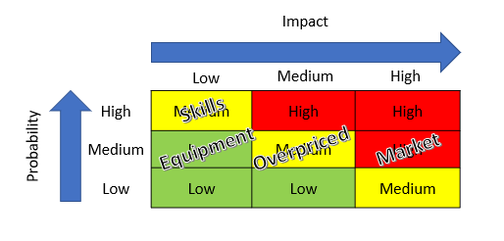Ensuring the solution offered by Abstineatis is affordable but still profitable for the business is a mitigation step to ensure that the solution is not overpriced and can compete in the market for process mining. A mitigation step to be taken to ensure that required skills are available is to offer training for personnel and businesses requiring the solution. This will not only empower individuals but create a more acceptable market. Scarcity of equipment can be mitigated by negotiating deals with companies that build the required equipment. Equipment can be imported to ensure the availability thereof.

Figure III‑1 Risk Matrix

# Initiative Investment

Abstineatis Process Mining is looking for an investment of R1 000 000 to aid in the establishment of the business. In return, we offer a 30% equity share in the business, with yearly dividends equal to 15% of the net profit generated. This slightly lower dividend share is to be put in place to retain a large share of the profits into the business, aiding in growth. This will also mean that the investment value (30% equity of the business) grows well. After the first five years of operation, there will be a buy-back option for the 30% equity at an amount to be negotiated at that time.

## Start-Up Capital

In this section, we discuss the costs associated with the establishment of the business.

First, to get the program up and running and limit the usage of the idea by possible competitors, we must establish a web presence. The following is required: to buy a domain name where the server can be allocated, and online assistance can be hosted.

Next, we must buy a licence for the program and make a patent application to limit the usage of algorithms designed and implemented in our software. This licence will require a yearly renewal of half the once-off buying price.

The costs associated with these steps are summarised in Table IV-1 below. For the first year of operation, distribution costs total R25 295.

Table IV‑1 Table showing expected distribution costs

|  |  |  |
| --- | --- | --- |
| Domain name | R 290,00 | per year |
| Licence Buy | R 16 470,00 | once-off |
| Licence Renew | R 8 235,00 | per year |
| Patent application | R 590,00 | one-off |
| Total distribution costs for year 1 | **R 25 295,00** | once-off |

The equipment required to run the software will be a server to host the software and databases, internet connection for the technician (due to our work from home model implemented to avoid facility cost). The technician will also require a laptop, which must be able to run complex software and maintain the server.

Instead of buying hardware for an on-site server, it was determined that the better option would be to hire a server at a monthly rate. When hiring a server, the server maintenance workload becomes less. We only need one technician responsible for software maintenance and tailoring for a new client. This was determined on the assumption of 6 clients growth per year. The costs described here are laid out in Table IV-2 below. Since the first operating year consists of only 6 months, these costs total R63 788.

Table IV‑2 Table Showing expected equipment costs

|  |  |  |  |  |
| --- | --- | --- | --- | --- |
|  |  |  | 6 Months | 12 Months |
| Technician Laptop | R 21 000,00 | one-off | Upgrade Yr 4 | |
| Server | R 1 199,00 | per month | R 7 194,00 | R 14 388,00 |
| Internet | R 4 599,00 | per month | R 27 594,00 | R 55 188,00 |
| Internet installation | R 8 000,00 | one-off |  |  |
| Total recurring equipment costs |  |  | R 34 788,00 | R 69 576,00 |
| Total start-up equipment cost | R29 000,00 | One-off costs | **R 63 788,00** |  |

These costs are reflected in the Financial Forecast (available in Appendix B). All told, total start-up cost (equal to total costs for the first year) add up to R864 173. Adding 15% as safety capital (to cover unforeseen expenses and cash flow until the company is established), the required capital for start-up totals R993 799. We, therefore, seek an investment of R1 000 000 with the terms described above.

## 1 Million Rand Runway

The start-up capital calculations showed that a million Rand is required to ensure that Abstineatis start well. Ensuring that enough capital is available to gather all resources for operating the business. This does not necessarily mean that Abstineatis will require a million Rand to survive the first year. This is because it is assumed that revenue will be generated in the first year of operations. It begs the question then of how far along the process a million Rand will take Abstineatis. This is both timewise and development wise.

Most of Abstineatis development will take place during the first year of operations. This is the acquisition of the required software, hardware and contracts to be able to operate as an entity. All other developments that will incur cost will be seen as operational costs. A million Rand spent on development will not only get Abstineatis in business, but it will also help to fund continuous development for a few years. That is if R750 000.00 is spent initially on developing the software and acquiring hardware and R85 000.00 is spent on maintenance and development.

How long will a million Rand last Abstineatis? Assuming that all cost of sales and overheads are equal per month, it can be calculated that a million Rand will cover all expenses for the first year of operation and the first four months of the second year of operations. This is also assuming that all revenue generated during this time is not used for expenses.

Does this then reflect the actual burn rate of Abstineatis? Yes and no. Yes, it represents the Gross burn of Abstineatis but not the Netto burn rate. The Gross burn rate for Abstineatis equates to 1.16 for the first-year values, and 2.91 for other years should a million Rand be available at the beginning of each year. This means that a runway of almost 14 months is possible with the first year's expenditures versus the almost 2 years and 11 months for the other years.

Using the first year and second year's expected revenue and expenditures, the Netto burn rate is calculated. For the first year, the Netto burn rate equates to 1.54 and -0.93 for the second year. This increase the runway for the first year to almost 19 months. Since profit is generated from the second year and on the Netto burn rate becomes obsolete. It rather indicates in what time a million Rand's worth of profit will be made. Using the second year's revenue and expenditures, just over 11 months to create a million Rand's profit.

Thus, a million Rand will pave the way to the success of Abstineatis should all assumptions made remain true.

Reference List

[1] I. T. F. o. P. Mining, "Process Mining Manifesto," in *Proceedings Business Process Mining Workshops*, ed: Springer, 2011.

[2] Gartner, "Market Guide for Process Mining," ed, 2019.

[3] P. e. a. Hutchison, "Cash-to-Cash Analysis and Management," *The CPA Journal,* pp. 1-5`, 2007. [Online]. Available: <https://www.researchgate.net/publication/260516599_Cash-To-Cash_Analysis_And_Management/stats>.

[4] W. Van der Aalst, *Process mining : data science in action*, 2nd ed. ed. Springer, 2016.

[5] M. Rosik, "3 Industries and Companies Doing Process Mining Right," in *Minit.io* vol. 2020, ed, 2018.

[6] AIMultiple. "Process Mining Software." (accessed 21 September, 2020).

[7] Celonis. "The Celonis Intelligent Business Cloud." <https://www.celonis.com/intelligent-business-cloud/> (accessed 21 September, 2020).

[8] UiPath. "UiPath Process Mining." <https://www.uipath.com/product/process-mining> (accessed 21 September, 2020).

[9] Minit. "Minit Process Mining is Powerful." <https://www.minit.io/software> (accessed 21 September, 2020).

# Appendix A: Business Model Canvas

|  |  |  |  |  |  |
| --- | --- | --- | --- | --- | --- |
| **Key Partners**  Software developers  Hardware suppliers  Business Analytics Trainers  Business Process Platforms (SAP, etc) | **Key Activities**  Software development  Hardware design and supply  Business Analytics Training | **Value Proposition**  Process Analytics  Training  Control over processes  Software  Direct contact with SA market | | **Customer Relationships**  Continuous support  Analytics interpretation  Customise a standard solution  Training | **Customer Segments**  IT logging  Manufacturing processes  Automated business processes  Medium sized companies |
| **Key Resources**  Business Process Platforms (SAP, etc)  Customer Relationships | **Channels**  Proof of concept models  Social media  Website  Testimonials |
| **Cost Structure**  Training staff  Software development  IT systems procurement and maintenance  Consulting staff  Customer Support | | | **Revenue Streams**  Training    System design and integration  Software sales  Consultation Fees | | |
| **Social and Environmental Cost**  Automation (job destruction) | | | **Social and Environmental Benefit**  Direct Job Creation  Indirect Job Creation | | |

# Appendix B: Financial Forecast & Plan

|  |  |  |  |  |  |  |  |  |  |  |  |  |
| --- | --- | --- | --- | --- | --- | --- | --- | --- | --- | --- | --- | --- |
| |  | | --- | |  | | **Abstineatis**  **5Y - Overview Financials** | | | | | | | | |  | |
|  | **Year of 2020** | **%** | **Year of 2021** | **%** | | **Year of 2022** | **%** | **Year of 2023** | **%** | **Year of 2024** | **%** |
| **Revenue** |  |  |  |  |  | |  |  |  |  |  |
| Program sale (Start-up R 20 000) | 120 000 |  | 400 000 |  | 400 000 | |  | 400 000 |  | 400000 |  |
| Subscription (R3 500 pm) | 63000 |  | 910 000 |  | 1512000 | |  | 2 352 000 |  | 3192000 |  |
| Consultation (R5 000) | 30 000 |  | 100 000 |  | 100 000 | |  | 100 000 |  | 100 000 |  |
| **Total Revenue** | 213 000 |  | 1 410 000 |  | 2 012 000 | |  | 2 852 00 |  | 3 692 000 |  |
| **Expenses** |  |  |  |  |  | |  |  |  |  |  |
| Cost of Sale | | | | | | | | | | | |
| Program design and maintenance | 624 800 |  | 15 000 |  | 15 000 | |  | 15 000 |  | 15 000 |  |
| Distribution | 25 585 |  | 8 525 |  | 8 525 | |  | 8 525 |  | 8 525 |  |
| Equipment | 63 788 |  | 69576 |  | 69576 | |  | 84576 |  | 69576 |  |
| **Total Cost of Sale** | 714 173 |  | 93 101 |  | 93 101 | |  | 108 101 |  | 93 101 |  |
| Overheads | | | | | | | | | | | |
| Salaries | 150000 |  | 250000 |  | 250000 | |  | 250000 |  | 250000 |  |
| Office hire  (Work from home strategy) | 0 |  | 0 |  | 0 | |  | 0 |  | 0 |  |
| **Total Overheads** | 150 000 |  | 250 000 |  | 250 000 | |  | 250 000 |  | 250 000 |  |
|  |  |  |  |  |  | |  |  |  |  |  |
| Net Profit | -651 173 |  | 1 066 89 |  | 1 668 899 | |  | 2 493 899 |  | 3 348 899 |  |